**Buea Municipal Council’s Business Management and Public Service Integrity Fellowship (BMF)**

**Improving Governance and Private Sector Expansion in Municipalities through Education**

***Offering Collective Learning, Skill Development Support, and Sharing of Best Practices***

***BMF slogan:*** *…Connecting the human capital of Buea municipality to the Nation’s National Development Agenda (Vision 2035)*

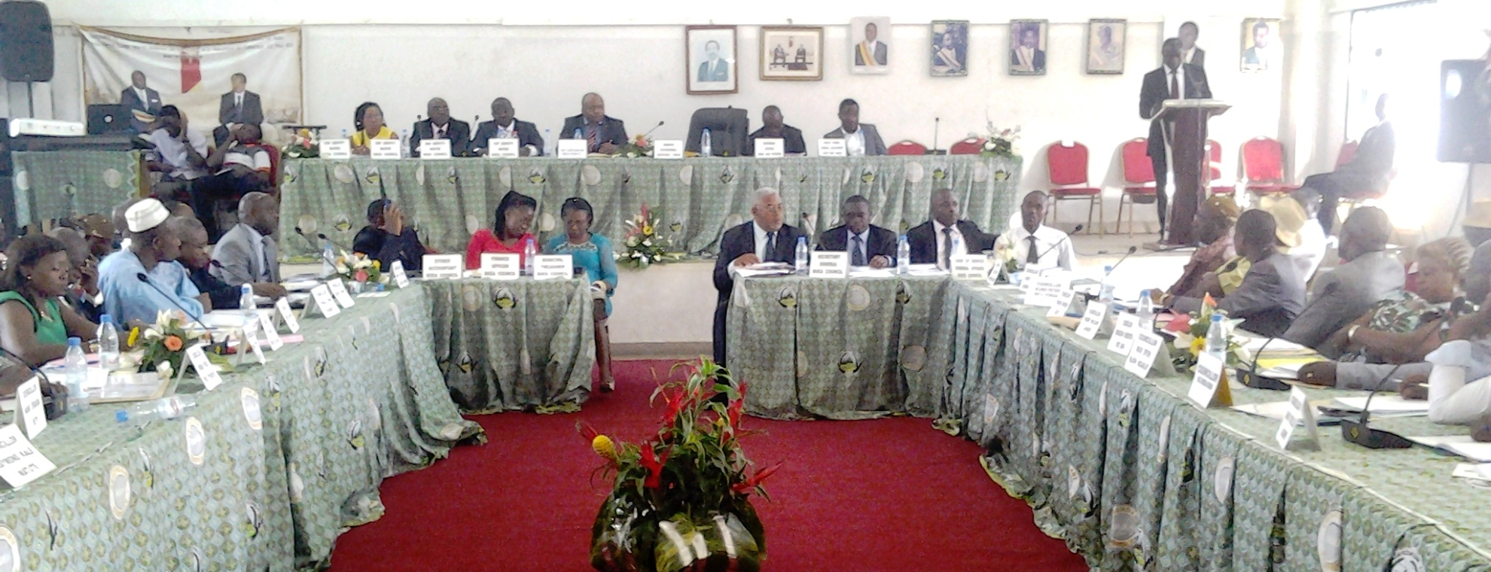

**What is the BMF**

BMF is a pioneering *Business Management and Public Service Integrity* professional development opportunity for the population of Cameroon in general, offered by Buea Municipal Council. It aims to overcome shortcomings in the development potential of ordinary citizens who constitute key players in the social, economic and political life of Cameroon and Buea municipality in particular. It is a partnership between the Buea Municipal Council and the International Governance Institute of the UK through its Cameroon chapter known as the Focal Integrity Team. The BMF supports young public servants in the civil service and private sectors, unskilled small business operators and young entrepreneurs; graduates from all works of life, including individuals who desire to improve their competencies in business management and local governance for the sustainable development of Buea Municipality and Cameroon in general.

The purpose of BMF is to help Cameroon recover lost grounds in governance, economic and social development as quickly as possible so as to keep pace and secure the realization of the National Vision by 2035. To this end the BMF’s professional development trainings and modules have been designed to provide implementation support at local government levels, to the following government policies and frameworks for Growth, Employment, Sustainable Development and Accountable National Governance:

* *The National Anti-Corruption Strategy of Cameroon*
* *International Monetary Fund (IMF)’s Enhanced Structural Adjustment Facility Medium-Term Economic and Financial Policy Framework*
* *Cameroon’s Development Strategy as expressed in the 2009 Growth and Employment Strategy and 2035 Vision put forward by the Ministry of Economy, Planning and Regional Development ( also known as WB Country Assistance Strategy for Cameroon)*
* *The National Governance Program [Project] of June, 2000 supported by the African Development Bank (AfDB).*

**Fellowship Facilitators**

BMF lecturers and facilitators are leading business management, anti corruption and good governance experts and practitioners from African/European universities and organizations; supported technically by a group of former chief executives from International Development organizations and the World Bank at Partnership for Transparency Fund in Washington DC.

The BMF will set the pace for the promotion of a sustainable private and public sector development driven by ordinary citizens to ensure improve governance, quality human resource for investment and development, thereby promoting collective well being as well as shared prosperity.

**Fellowship Objectives (BMF)**

Bearing in mind that the message of refusing to give or take a bribe will not erase poor governance overnight including the shortfall of integrity and professionalism by business and public operators in the Cameroonian system, IGI-FITCAM is engaging in a unique innovation of changing mindsets and attitudes through an approach of collective education, skill development support and sharing of best practices in business administration and public service governance; to improve civic performance and curb public sector corruption, thereby reducing the corruption perception index of Cameroon internationally and nationally.

In this respect BMF has the following as objectives:

**Long term:**

* Promote professional education which is tailored to support the realization of our national development policies and growth strategies in public life through the stratagem of municipal council fellowships

**Short and medium term:**

* To provide training in best practices in business administration and management to 10,000 private sector operators in the municipality over a period of 5 years; and to be continued after the pilot phase for a lifelong period.
* To increase the ability of 20,000 private and public sector operators in local metropolis to contribute to efforts of transparency, integrity and accountability in their distinct sectors of assignment thereby engaging them as agents of change
* To support the Governance, Growth and Development Agenda of the Government of Cameroon as established through policy by means of quality human resource development and learning against corruption
* To increase Cameroon Human Resource Competitiveness locally thereby ensuring investors security in the Municipality including improvement in well-being of the population.

**Benchmark for Measuring Our Success**

The Fellowship will contribute to the following impact:

* Significant increase in fellows’ human resource competitiveness and ability to participate and contribute to development locally and nationally
* Remarkable increase in fellows business management and public service integrity aptitude; especially young public servants in the civil service and operators of small and medium enterprises in Cameroon; thereby contributing to the improvement of local governance and private sector expansion in Buea municipality and beyond
* Fellows receive professional mentoring and skill development support tailored for the achievement of the national vision by 2035
* Availability of quality human resource to sustain investment and development of new businesses in both the formal and informal sectors in Buea municipality is guaranteed

**Benefit of the Fellowship**

Successful public organisations whether large or small; private or public are well managed; the development of management skills alongside public service integrity within an organisation is an essential part of continued business growth and collective prosperity. The fellowship is a capacity development support program in modern business management and good local governance practice with the aim of enriching your performance and expertise in the growing and evolving profession of business management and public service accountability.

* It offers you a unique opportunity to gain knowledge on a range of practical skills that will make you marketable and competitive in the workplace; increase your value to public service customers and to future employers.
* It offers you the opportunity to become a certified fellow of the *Business Management and Public Service Integrity fellowship offered by Buea Municipal Council and International Governance Institute of the UK*
* Upon successful completion of BMF you will be offered a *Certificate of Professional Training in Business Management and Public Service Integrity* which can be used to take further professional programs offered by UK Association of Business Executives (ABE) through Enterprise Institute.

**Application Process**

**The Buea Municipal Council Fellowships (BMF) are awarded to deeply committed individuals willing to conduct actions that demonstrate compliance with ethics and best practices in the management of their businesses and service to the Cameroonian public. Before the fellowship you will need to provide a summary of your current work as linked to community service. After the fellowship you will need to provide a brief report on how the fellowship has and continue to impact your work and management practice including links/ pictures in support of these details. Please note that due to an absence of a volunteer translator in the *French language,* the BMF’s working language is currently English. Applications must be filled and submitted in English.**

**Apply for a Full Scholarship**

While public trust in public servants and business operators globally is running low there is a real need to ensure that investments in Cameroon are protected. According to Doing Business in Cameroon published by the Foreign and Commonwealths Office Cameroon’s economic growth is expected to accelerate over the next five years period from an official estimated of 4.1 percent GDP in 2011 to an average of 4.5 percent in 2016 going forward. One of the incentives to pushing our economic and social develop growth rate even further is to ensure the availability of skilled professionals capable of providing support for the improvement of our governance and macro economic situation. To this end the Lord Mayor of Buea Municipality is offering a number of full scholarships for fellows to participate in the Business Management and Public Service Integrity Fellowship that is jointly organized by the International Governance Institute of the UK and Buea Municipal Council in Buea, Cameroon. To benefit from this scholarship ( alongside your application) you must write a short essay of not more than 200 words each explaining your understanding of the following national development policy documents:

* The National Anti Corruption Strategy of Cameroon (200 words)
* The National Governance Program of Cameroon (200 words)
* Cameroon Development Goals by 2035 (200 words)

Again in your essay you will need to describe briefly what these policies seek to achieve and how you would contribute as an individual to the realization of each. Preferably in this section we strongly suggest you prepare an additional proposal of a project you will like to embark on after the fellowship in no more than 200 words spelling out its purpose, objectives, indicators of success as well as your projects impact on the growth and employment of the population of Buea Municipality. The total number of expected word limit on your BMF scholarship application form is 800 words.

With BMF we desire to provide greater support to the growth and development of your potentials. Interested in BMF apply here to be considered for a scholarship.

**BFM Assessment Criteria**

Applications for the BMF program will be assessed against the following criteria:

1. Nature of current volunteer assignment, business or public service task and how it contributes to the growth and employment of Buea municipality and the national vision in general.
2. Quality of essays submitted and respect for word limits
3. Relevance of proposed project proposal for the growth and development of Buea municipality including Cameroon’s 2035 development goals in general
4. Ability to understand and assimilate the fellowship program content
5. You should be able to demonstrate the contribution that you will make to promote integrity education and fight against corruption in Buea municipality and Cameroon in general
6. We will also be looking for motivation, self direction and properly developed interpersonal skills that hold potential for community leadership.

**Who is Eligible**

Eligibility for BMF is opened to the following group of individuals who meet the following conditions:

* Young public servants in the civil service and private sectors
* Unskilled small business operators and young entrepreneurs
* Graduates from all works of life, including individuals who desire to improve their competencies in business management and local governance for the sustainable development of Buea Municipality and Cameroon in general.
* Holders of an official government Identification Card (ID)

**Our Team**

**BMF Program Coordinator**

Stephen Asek

**BMF Facilitators Manager**

Mr. Hoffman Betika

**BMF Impact Assessment and Monitoring Specialist**

Mr. Chamango Blaise

**BMF Fellows Relation and Logistics Officer**

Mr. Achouna Didero

**BMF Information Technology Specialist**

Activ Spaces c/o Mr. Otto Akama. Please contact BMF program staff at [bmfcouncil@bmf.org](mailto:bmfcouncil@bmf.org)

**Current BMF Facilitators**

**Mr. Hoffman Betika Ayuk**

*Anglia Ruskin University, London UK*

**Mr Stephen Asek**

*London South Bank University, London, UK and African Commonwealth Scholar;*

*Fellow of the Fletcher School of Law and Diplomacy, USA*

**Mr. Maximilian Borchardt**

*Bauhaus-Universität Weimar, Germany*

**Mr. Okesack Thompson**

All Bright Company Limited

**Mr. Yusuf Konyalicetin**

*Justus-Liebig Universität, Giessen, Germany*

**BMF Board of Governors**

The BMF Board of Governors is our senior decision making body which is responsible for determining the fellowship strategy and priority actions to meet its stated objectives. The BMF Board of Governors is made up of the BMF program coordinator and 3 senior management staff of Buea Municipal Council. The BMF Board Chair is the acting Lord Mayor of Buea Municipality who presides over BMF annual Board of Governors meetings. Current BMF Board of Governors are:

**The Mayor of Buea Municipal Council**

Mr. Ekema Patrick Esunge

**BMF Program Coordinator**

Mr. Stephen Asek

**2st Assistant Lord Mayor of Buea Municipal Council**

Mr. John Efande Lyonga

**The Secretary General of Buea Municipal Council**

Mr. Joseph Ewome Njie

**BMF Technical Advisors**

BMF technical advisors are PTF’s experts drawn from different parts of the world with extensive experience of anti-corruption, rule of law, policy implementation and international economic development. They provide regular coaching and mentoring on diverse aspects of the fellowship to ensure that the fellowship impact on the development of ordinary citizens and the community. PTF advances innovative citizen led actions to improve governance, promote transparency and reduce corruption in developing countries. To view PTF experts click here <http://ptfund.org/board-directors> .

**BMF Tailored Professional Courses and Modules**

Combination of unique experiential learning and academia level learning that provide a broad curriculum of professional skill development.

Day 1

* The God Reward for Service
* The Business Environment
* Stakeholders Analysis

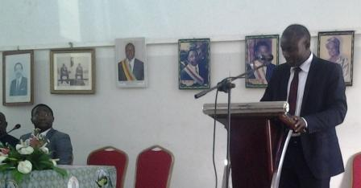

* Strategic Change Leadership

Day 2

* Understanding Corruption, Its causes, effects and consequences
* Public Service Corruption Risk Assessment & Management
* Strategic Human Resource Management
* Corporate Strategy

Day 3

* Economics of Happiness (Video session)
* Anti Corruption What it Means to the Cameroonian Economy
* Policy Development, Analysis and Implementation; Understanding the Difference Between Governance and Good Governance
* Explaining Vision 2035: Understanding the Growth and Employment Strategy Objectives of Cameroon and Cameroon’s Development Goals

Day 4

* Project Management
* Marketing Policy, Planning, and Communication
* Financial Accounting
* Nonviolent Discipline and Communication ( Video)

Day 5

* Understanding Entrepreneurship
* Group Presentation of Lessons Learned by Learners
* Closing Ceremony & Award of Fellowship Certificates

Download copy of fellowship program **here**

**Key Strategic Government Policy Documents used in Fellowship Framing**

* The National Anti Corruption Strategy of Cameroon
* The World Bank Country Assistance Strategy for Cameroon
* The Growth and Employment Strategy of Cameroon (covering Cameroon Development Goals and Vision 2035
* The International Monetary Fund (IMF)’s Enhanced Structural Adjustment Facility Medium-Term Economic and Financial Policy Framework
* The National Governance Program of Cameroon
* Foreign and Commonwealth Office: Doing Business in Cameroon Report

**Meet Our Current Fellows page**

**Learn about the sights and Sound of Buea Municipality**

Official Partners:





Image result for activ spaces logo



Buea Municipal Council

Document prepared by Stephen Asek